**CA Lab 08 Report**

**Task01**

module Instruction_Memory

(

input[63:0] Inst_Address,

output reg[31:0] Instruction

);

reg[7:0] Inst_Mem[15:0];

//initialize acc to fig:8.3

initial

begin

Inst_Mem[0] = 8'b10000011;

Inst_Mem[1] = 8'b00110100;

Inst_Mem[2] = 8'b00000101;

Inst_Mem[3] = 8'b00001111;

Inst_Mem[4] = 8'b10110011;

Inst_Mem[5] = 8'b10000100;

Inst_Mem[6] = 8'b10011010;

Inst_Mem[7] = 8'b00000000;

Inst_Mem[8] = 8'b10010011;

Inst_Mem[9] = 8'b10000100;

Inst_Mem[10] = 8'b00010100;

Inst_Mem[11] = 8'b00000000;

Inst_Mem[12] = 8'b00100011;

Inst_Mem[13] = 8'b00111000;

Inst_Mem[14] = 8'b10010101;

Inst_Mem[15] = 8'b00001110;

end

always@(*)

begin

//concatenate Inst_Mem[Inst_Address+3:Inst_Address] as output Instruction

assign Instruction = { Inst_Mem[Inst_Address+3], Inst_Mem[Inst_Address+2] ,Inst_Mem[Inst_Address+1], Inst_Mem[Inst_Address]};

end

endmodule

module tb

(

);

reg[63:0] Inst_Address;

wire[31:0] Instruction;

Instruction_Memory instruction_memory

(

.Inst_Address(Inst_Address),

.Instruction(Instruction)

);

initial

begin

Inst_Address = 64'd0;

#400

Inst_Address = 64'd4;

end

endmodule

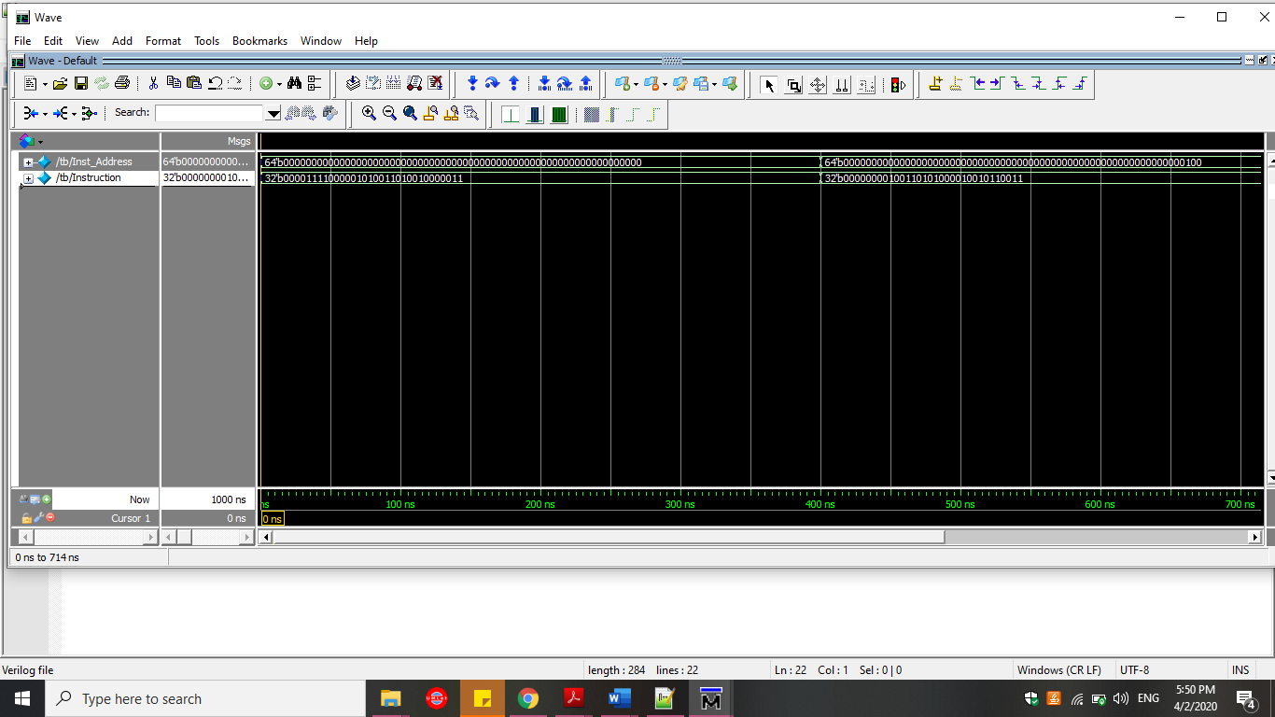

**Exercise**

module Data_Memory

(

input[63:0] Mem_Addr, Write_Data,

input clk, Mem_Write, Mem_Read,

output reg[63:0] Read_Data

);

reg [7:0] DM [63:0];

integer i;

initial

begin

for (i=0; i<64; i=i+1)

DM[i] = i;

end

always@(posedge clk)

begin

if (Mem_Write == 1)

begin

DM[Mem_Addr] = Write_Data[7:0];

DM[Mem_Addr+1] = Write_Data[15:8];

DM[Mem_Addr+2] = Write_Data[23:16];

DM[Mem_Addr+3] = Write_Data[31:17];

DM[Mem_Addr+4] = Write_Data[39:18];

DM[Mem_Addr+5] = Write_Data[47:40];

DM[Mem_Addr+6] = Write_Data[55:48];

DM[Mem_Addr+7] = Write_Data[63:56];

end

end

always@(Mem_Addr or Mem_Read)

begin

if (Mem_Read == 1)

begin

Read_Data = { DM[Mem_Addr+7], DM[Mem_Addr+6], DM[Mem_Addr+5], DM[Mem_Addr+4], DM[Mem_Addr+3], DM[Mem_Addr+2], DM[Mem_Addr+1], DM[Mem_Addr] };

end

end

endmodule

module tb

(

);

reg[63:0] Mem_Addr, Write_Data;

reg clk, Mem_Write, Mem_Read;

wire[63:0] Read_Data;

Data_Memory data_memory

(

.Mem_Addr(Mem_Addr),

.Write_Data(Write_Data),

.clk(clk),

.Mem_Write(Mem_Write),

.Mem_Read(Mem_Read),

.Read_Data(Read_Data)

);

initial

begin

clk = 0;

Write_Data = 64'd10;

Mem_Addr = 64'd0;

Mem_Write = 1;

Mem_Read = 1;

#100

Mem_Addr = 64'd8;

Mem_Read = 0;

#100

Write_Data = 64'd4;

#50

Mem_Read = 1;

end

always

#50 clk = ~clk;

endmodule

